Contact [Name, Position]  Telephone [Phone Number]  Cell [Cell Phone]  Email [E-mail]  Website [Website] | For Immediate Release  [Date]

[Main Title of Press Release]

[Subtitle of Press Release]
[City Name], MN, [Date]— [Insert 1–2 sentences announcing your project has received a grant and briefly describe what the funding will support. Clearly state “who,” “what,” “when,” “where” and “why.”]
[Insert a quote from an executive or leader at your organization about what the announcement means.]
[Add additional paragraph(s) as necessary to describe your announcement and the benefits it provides.]
[Specify the role of the MWMO and other project partners, as appropriate.]
[Request a quote from the MWMO and/or another partner organization, if appropriate. Include the person’s title and/or role at the organization.]
[Before you end, make sure to briefly describe your organization and what you do.]
# # #
If you would like more information about this topic, please contact [Your name] at [Phone Number] or email at [E-mail].

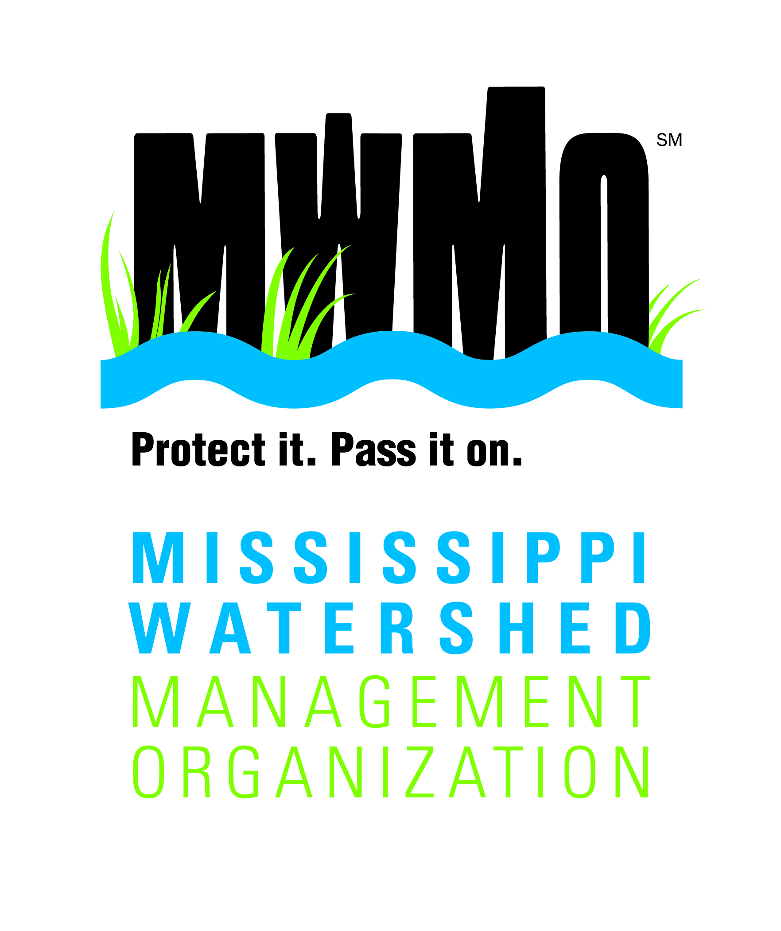
About the Mississippi Watershed Management Organization
The Mississippi Watershed Management Organization is a special-purpose unit of local government that works to protect and improve water quality and habitat in an urban watershed. The MWMO invests in people and infrastructure to support clean water, and provides knowledge, scientific data and expertise to help manage our vital water resources. Learn more at mwmo.org.

[Add other partner logos and descriptions, as appropriate.]

